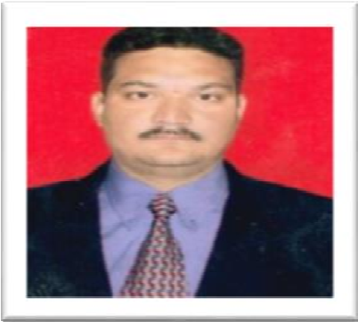
Faculty members

Name | Dr. Brij Nandan
Designation | Chief Scientist cum Prof.(Agronomy) & Incharge PRSS, Samba
Area of Specialization | Pulse Agronomy, Intercropping Cropping system, organic and natural farming in pulses.
Email | prsssamba@gmail.com , bmankotia333@gmail.com
Contact No. | 7006634653
Professional Experience | 21 years
Awards/Honours/Scholarships /Fellowship | 07
Research Interests | Pulse Weed Management , Organic farming , Nutrient Management, Conservation Agriculture Natural  Resource management
Total number of Publications | 145
Selected Publications (Best Five) | 12 International Publications
No. of Books/Manuals/Monographs | 06
Research Projects as PI/ Nodal Officer | AICRP on Rabi Pulses (Agronomy) ,  AICRP on Kharif pulses ( Agronomy)  Pulses Seed Hub (Nodal Officer)
Technologies developed | 15
Other Achievements if Any (Please Specify) | Principal Investigator in identification ,developing production technologies and promotion of the two leading Kharif pulses varieties of Jammu region IPM-02-3/ PU-31 and various rabi pulses varieties  GNG1581, GNG1958, Parkash, Aman and PL-6,PL-7 and PL-8  Life member of 07 Scientific societies  Councillor : 02 Societies (Recent Past)  Reviewer of various national and international Journal  Students guided: 10  Students under guidance : 01  Associated in Teaching of UG and PG courses of Agronomy Division

Projects concluded: As PI: 03
As Co-PI:02
Research Projects: Ongoing: 03

